Project Objectives

- To develop a sustainable high-output grass-based spring milk production system
- To incorporate the most recent advances in grassland management for dairy farms into a high- output system
- Use a type of dairy cow that has good genetic indices for both milk production and fertility
- Employ the best practices from nutrition research and dairy cow husbandry
- Incorporate nutritional studies into a high-output system
- To incorporate management technologies and system attributes that enhance the sustainability of dairy production
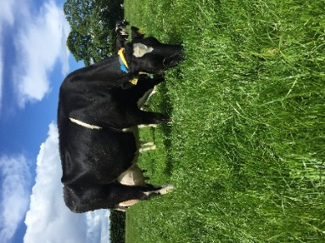
Farm Details Week 17/04/23
Stocking rate on MP (LU/ha) | 4.66
Farm Cover (DM/ha) | 809
Growth Rate (DM/ha/day) | 46
Demand (DM/ha/day) | 56
Average grass DM (%) | 18.2
Average Concentrate fed (kg/day) | 7.78
Average DIM | 55
Area Grazed (%) | 100

Cow Details Week 17/04/23
Yield (kg/cow/day) | 33.33
Fat (%) | 4.10
Protein (%) | 3.42
MS (kg/day) | 2.40
SCC | 58,150

Grassland Management:
With the increase in temperature, grass growth has lifted, so we were able to close 3 paddocks (3.16 ha) for silage. Two paddocks (2.04 ha) were sprayed off last week and have now been reseeded with a tetraploid only mixture (Aberclyde, Abergain, Gracehill) sown at 31 kg/ha plus clover at 3 kg/ha. All varieties used have been selected from the Irish recommended list 2023.

Comments:
On the 12th of April cows were weighed and averaged 565kg (474 kg for 1st lactation cows, 524 kg for 2nd lactation, 576 kg for 3rd lactation and 618 kg for 4th + lactation cows).
Cows are showing good breeding activity ahead of the breeding season with breeding start date planned for May 2nd.

For more details on the High Output Systems Research Herd visit
https://www.ucd.ie/agfood/about/lyonsresearchfarm/lyonsdairyherd/

